MD2201: Data Science

Name of the student: Shrinivas Hatyalikar Roll No. 24

Div: B Batch: B1

Date of performance: 22/09/22

Experiment No.2

Title: Laboratory on Statistics
Aim: To find the probability for Binomial distribution and Normal distribution and verify the Normal approximation of Binomial distribution.

Software used: Programming language R.

Code Statement:
Write a single R code to answer the following questions.

Data Set: Travelled Abroad

- Find out the % of Indians in the sample who have travelled abroad using the data source.
- Treating this value as ‘p’, calculate the following probabilities –
  - What is the probability that in a randomly chosen sample of 10 persons, no one has travelled abroad?
  - What is the probability that in a randomly chosen sample of 10 persons, exactly one has travelled abroad?
  - What is the probability that in a randomly chosen sample of 10 persons, exactly two persons have travelled abroad?
  - What is the probability that in a randomly chosen sample of 10 persons, exactly three persons have travelled abroad?
  - What is the probability that in a randomly chosen sample of 10 persons, exactly four persons have travelled abroad?
  - What is the probability that in a randomly chosen sample of 10 persons, exactly five persons have travelled abroad.
  - What is the probability that in a randomly chosen sample of 10 persons, exactly six persons have travelled abroad?
  - What is the probability that in a randomly chosen sample of 10 persons, exactly seven persons have travelled abroad?
  - What is the probability that in a randomly chosen sample of 10 persons, exactly eight persons have travelled abroad?
  - What is the probability that in a randomly chosen sample of 10 persons, exactly nine persons have travelled abroad?
  - What is the probability that in a randomly chosen sample of 10 persons, all 10 persons have travelled abroad?
- Plot the probability values as a Table / Bar graph/plot and interpret plot.

- What is the probability that in the randomly chosen sample of 100 persons at least 59 have travelled abroad?
Hint: Expected to perform Normal approximation for the binary distribution.

Code:
f1<- read.csv("travelled abroad_csv.csv")

#Percentage of Indians who have travelled abroad
percentage<-sum(f1$Travelledabroad=="Y")/nrow(f1)*100
cat("\nPercentage of people travelled abroad:",percentage)

#Probability
p<-percentage/100
cat("\nProability of success:",p)

#dbinom() is the function for finding prob. with binomial distribution
#dbinom(k,n,p)
#Probability in a random sample from k=0 to k=10
k=0:10
pb<-dbinom(k,10,p)
cat("\nProbabilty for k=0 to 10 by Binomial Distribution: ",pb)

plot(k,pb,type="l")

k1=59:100
probin<- sum(dbinom(k1,100,p))
cat("\nProbability for k>=59 by BD ",probin)

#pnorm() is the function for finding prob. using normal distribution
#pnorm(observed,mean,sd)
#BD to ND 2 conditions
#1) np>10 and 2) n(1-p)>10
mean<-100*p #mean = np
cat("\nMean:",mean)
sd1<-sqrt(mean*(1-p)) #standard deviation = root(mean(1-p))
cat("\nStandard Deviation:",sd1)
pronrm<-pnorm(59,mean,sd1,lower.tail = F)
cat("\nProbability for K>=59 by Normal Distribution",pronrm)
k2=0:100
d<-dbinom(k2,100,p)
plot(k2,d,type="l")

Results:

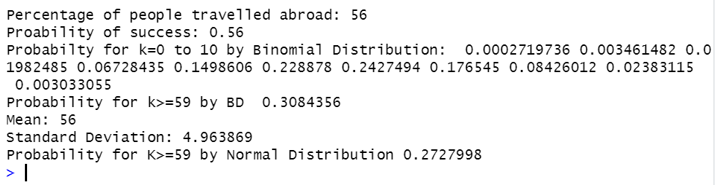

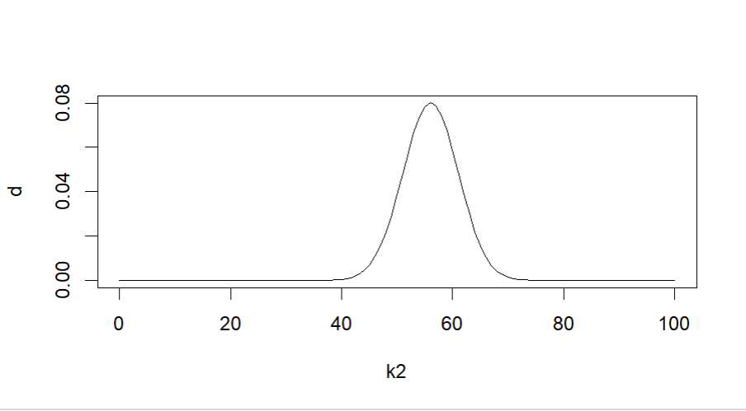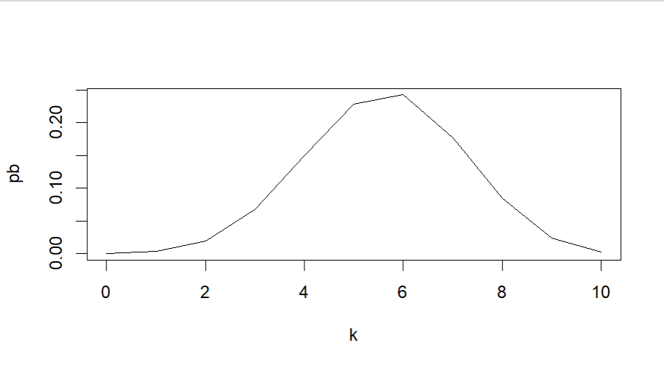

Conclusion:

Dbinom() function is used to compute probability using a binomial distribution. The conditions np>10 and n(1-p)>10 must be met in order to calculate the probability using the normal distribution. The condition is not satisfied because n=10, as can be seen in the first case, and the resulting curve is not smooth. The requirement is met in the second example because n=100, and the probability may be determined using the pnorm() function. Additionally, the generated curve is smooth and displays a normal distribution.

